VE482 LAB1 REPORT

Name: Chen Yaxin

Student ID: 517021911020

**1 Hardware overview**

In the computer locate:

* The motherboard

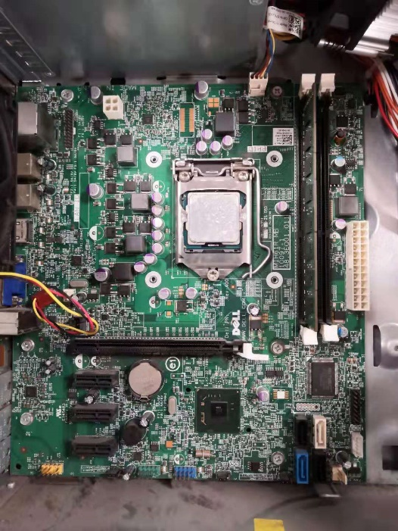

* The PC power supply

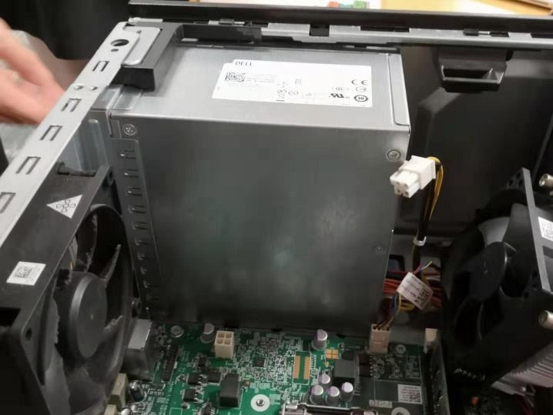

* A Hard Disk Drive

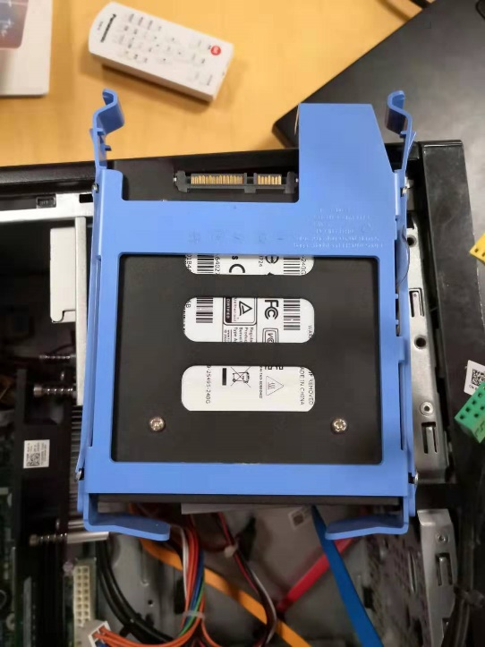

* A PCI card (missing)

Expected location:

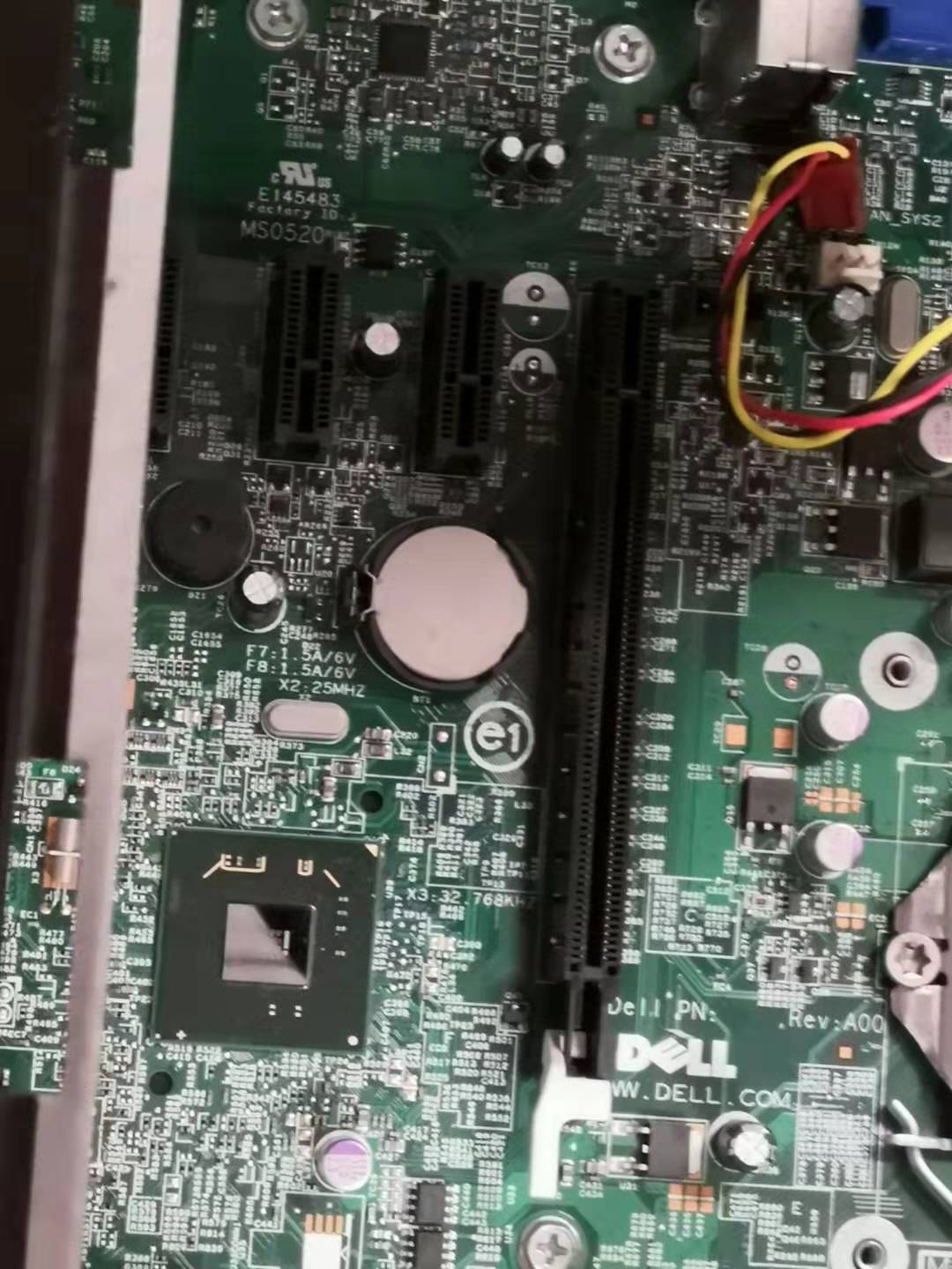

* An Optical disk drive

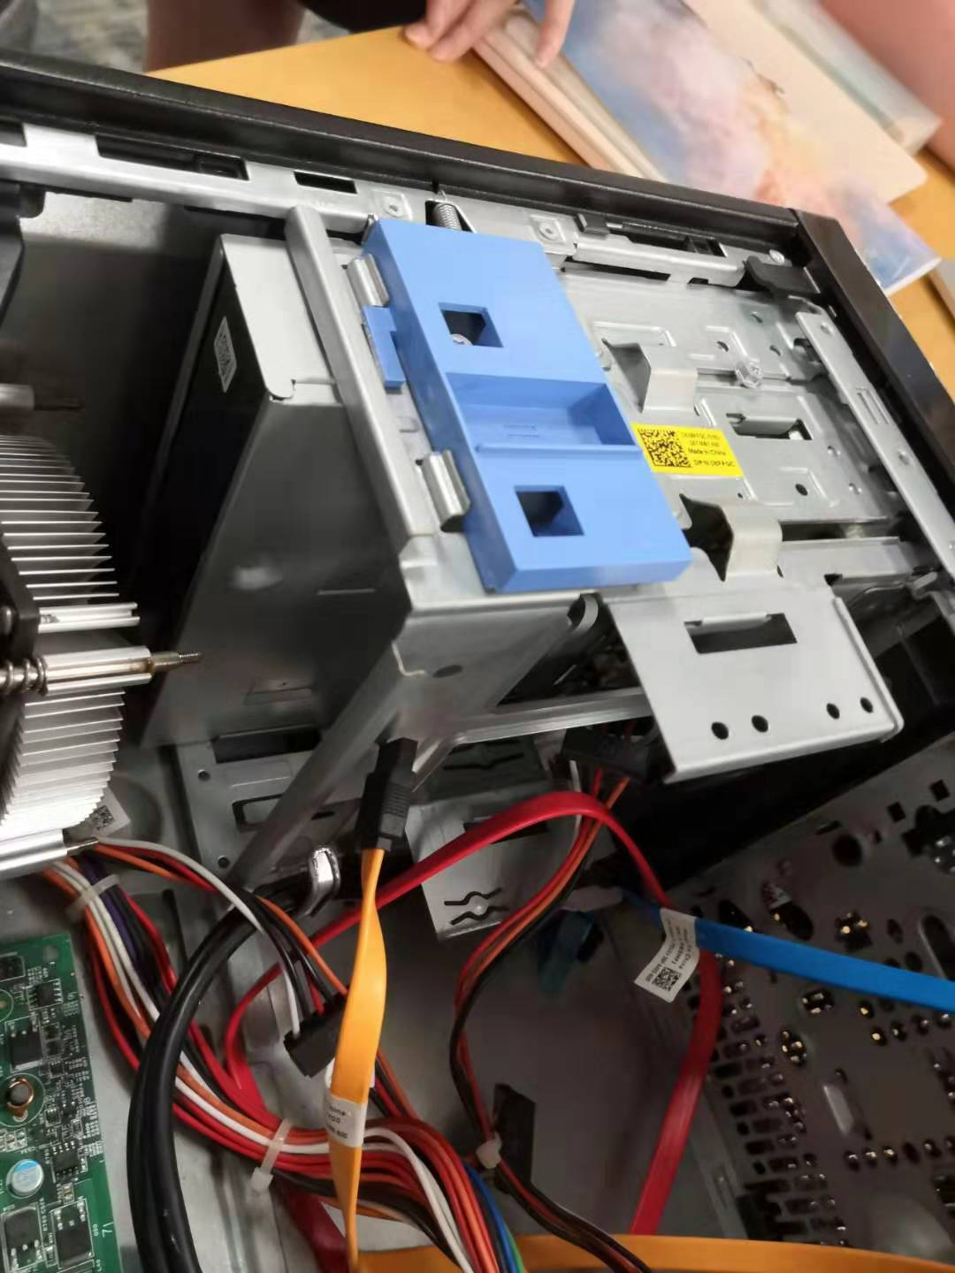

On the motherboard locate:

* The RAM

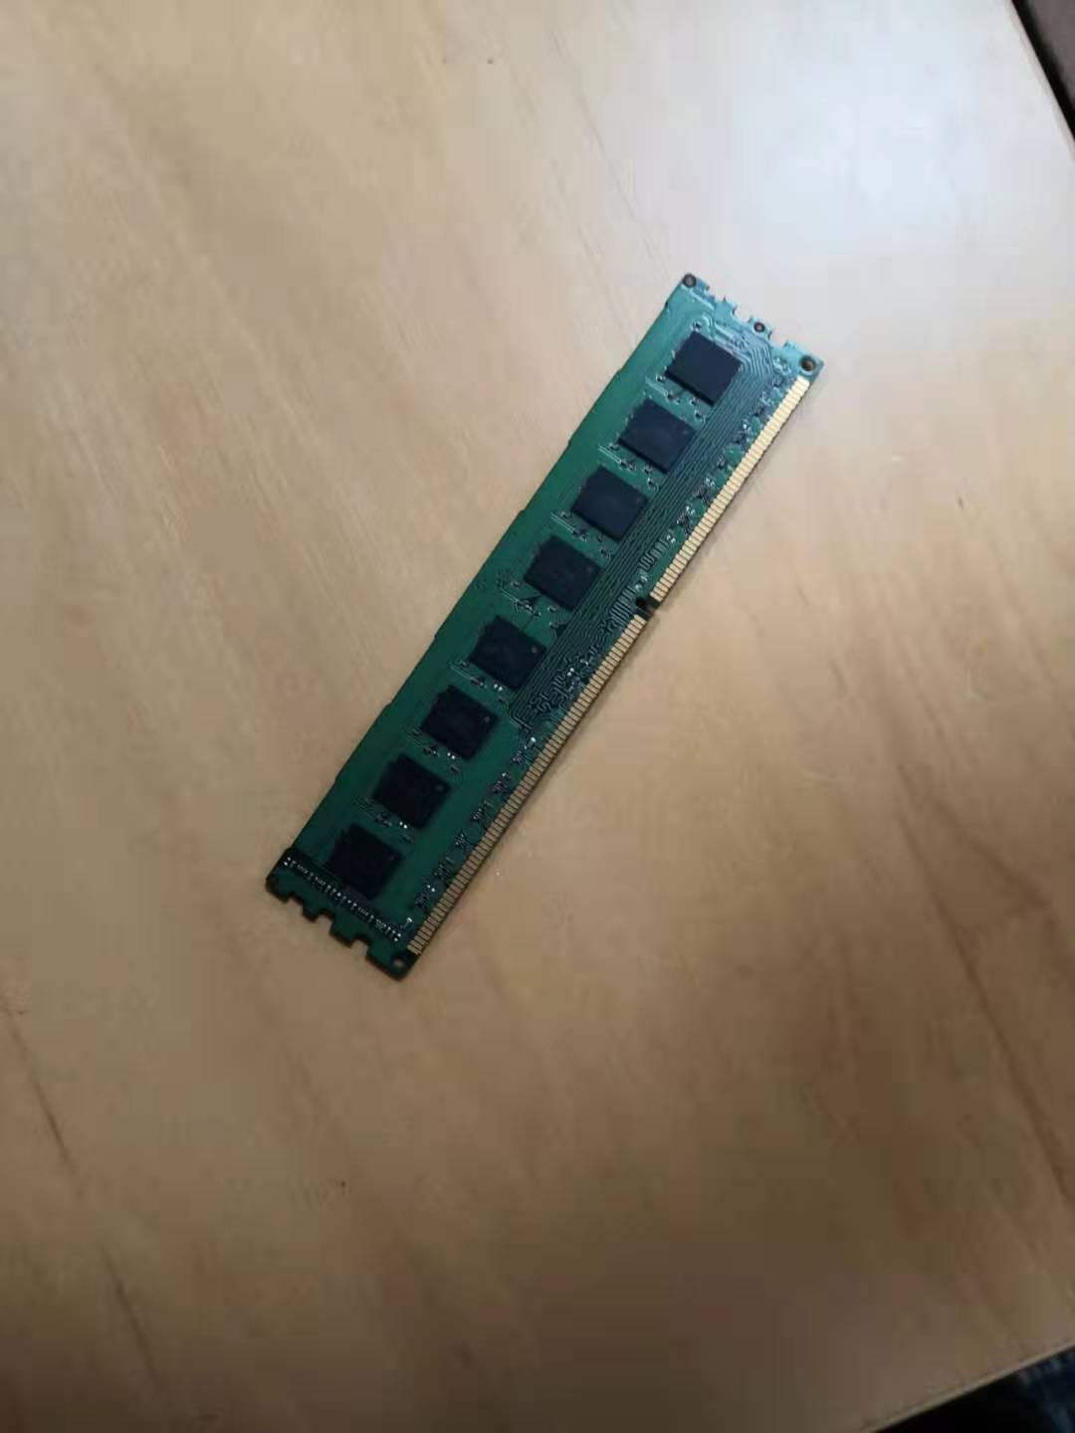

* The North and South bridges

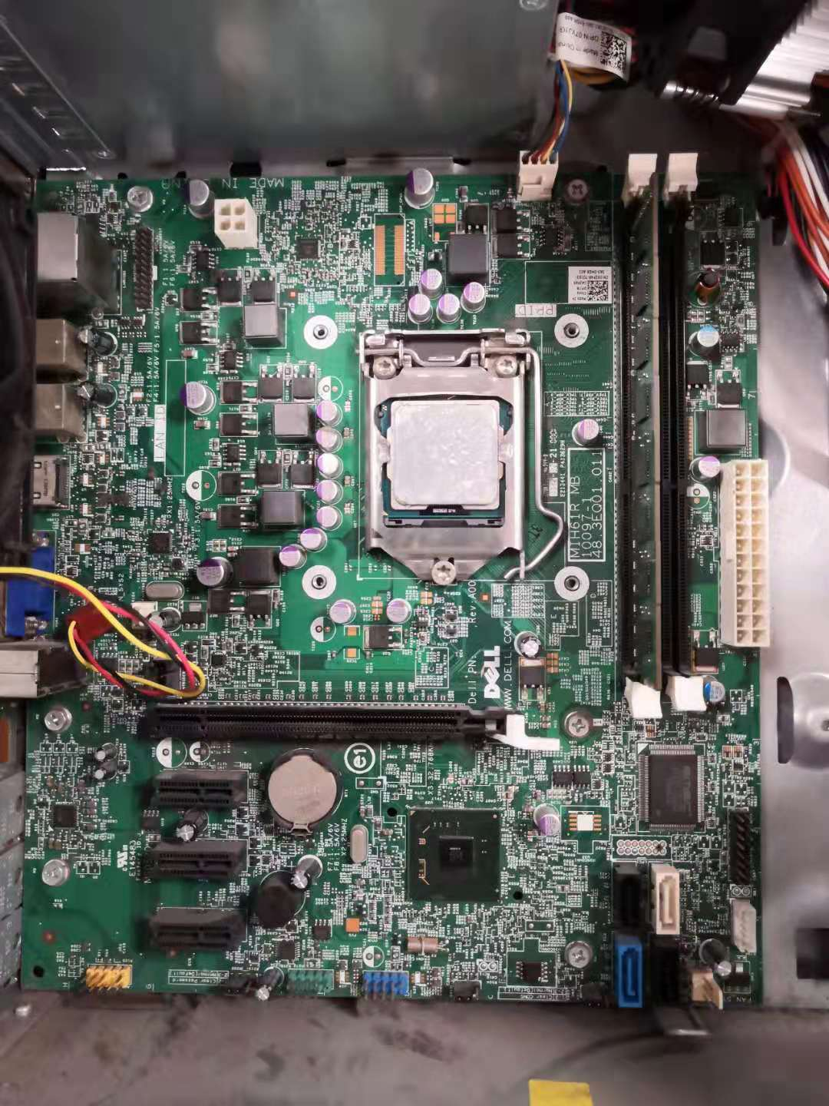

* A SATA socket

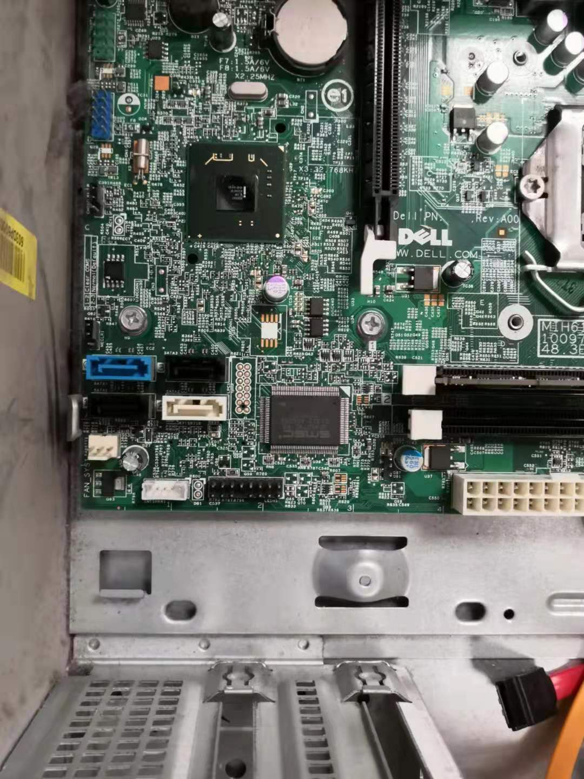

* The battery

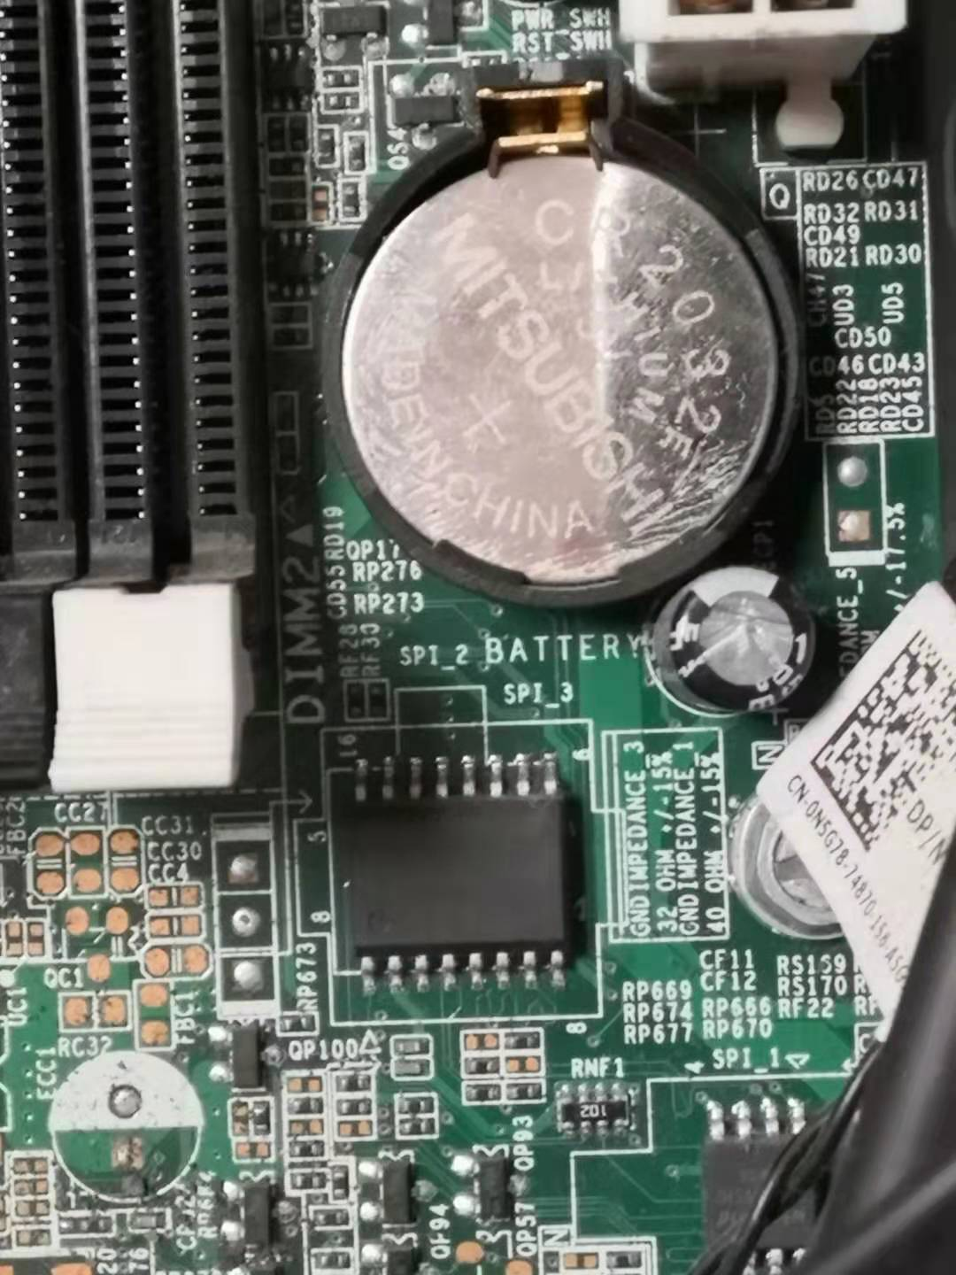

* A PCI/PCI-e slot



* The CPU



* The BIOS



• Where is the CPU hidden, and why?

**Under the fan. To prevent the temperature of CPU from being too high.**

• What are the North and South bridges?

**North and South bridges are integrated circuits that manage communications between the CPU and other components on the motherboard.**

• How are the North and South bridges connected together?

**They are connected by a bus.**

• What is the BIOS?

**Basic Input/Output System. It is stored in a ROM chip and instructs computer on how to input/output, configure hardware and boot.**

• Take out the CPU, rotate it and try to plug it back in a different position, is that working?

**No.**

• Explain what overclocking is?

**Overlocking is the action of increasing the clock rate of the computer to exceed the speed it was designed to run.**

• What are pins on a PCI/PCI-e card and what are they used for?

**They are I/O ports and they are used to connect more peripheral devices to the computer.**

• Before PCI-e became a common standard many graphics cards were using Accelerated Graphics Port (AGP), explain why.

**AGP is designed for video cards and computer graphics. It is high-speed and provides a dedicated pathway between the graphics controller and the main memory.**

**2 Basic shell**

• Use the mkdir, touch, mv, cp, and ls commands to:

– Create a file named test.

**touch test**

– Move test to dir/test.txt, where dir is a new directory.

**mkdir dir**

**mv test dir/test.txt**

– Copy dir/test.txt to dir/test_copy.txt.

**cp dir/test.txt dir/test_copy.txt**

– List all the files contained in dir.

**ls -a dir**

• Use the grep command to:

– List all the files from /etc containing the pattern 127.0.0.1.

**grep 127.0.0.1 /etc/\***

– Only print the lines containing your username and root in the file /etc/passwd (only one grep should be used)

**grep ‘cyx\|root’ /etc/passwd**

• Use the find command to:

– List all the files from /etc that have been accessed less than 24 hours ago.

**find /etc –atime 0**

– List all the files from /etc whose name contains the pattern “netw”.

f**ind /etc –name “*netw*”**

• In the bash man-page read the part related to redirections. Explain the following signs >, >>, <<<, >&1, and 2>&1 >. What is the use of the tee command.

**[n] > [file] : redirect the file descriptor n to the file; redirect the standard output if n is not specified.**

**[n] >> [file] : append the file descriptor n to the file; apppend the standard output if n is not specified.**

**[n] <<< [word] : Here Strings. [word] is supplied to the command on its standard input after undergoing brace expansion, tilde expansion, parameter and variable expansion, command substitution, arithmetic expansion, and quote removal.**

**[n] >&1: duplicate file descriptor n from standard output**

**2>&1 > : duplicate the standard error from the standard output, then redirect the standard ouput.**

**tee: read from standard input and write to standard ouput and files**

• Explain the behaviour of the xargs command and of the | sign.

**xargs: build and execute command lines from standard input. It reads items from the standard input, delimited by blanks or new lines, and executes the command one or more times with any initial-arguments followed by items read from standard input. Blank lines on the standard input are ignored.**

**the | sign: the output of the former command serves as input to the next.**

• What are the head and tail commands? How to “live display” a file as new lines are appended?

**head: outputs the first part of files**

**tail: outputs the last part of files**

**“live display”: tail –f [={name|descriptor}]**

• How to monitor the system using ps, top, free, vmstat?

**ps: reports a snapshot that displays information about a selection of the active processes.**

**top: displays linux processes dynamically.**

**free: displays the total amount of free and used physical and swap memory in the system, as well as the buffers and caches used by the kernel.**

**vmstat: report virtual memory statistics**.